General Biology Year 11 2021

Unit 1 – Classification and cell processes

Task 6: Test – Cell processes

(weighting 10%)

MARKING KEY

|  |  |  |  |
| --- | --- | --- | --- |
| **Name:** | **Teacher:** | **Date:** | **Score:**  / |

**Time permitted: 60 minutes**

|  |  |  |  |  |
| --- | --- | --- | --- | --- |
|  | Section | Number of questions | Marks available | Marks achieved |
| A | Multiple choice | 12 | 12 |  |
| B | Short answer | 14 | 24 |  |
| C | Extended answer | 2 | 7 |  |
|  | **Total** | **28** | **43** |  |

**Comments:**

________________________________________________________________________________________________________________________________________________________________________________________________________________________________________________________________________________________________________________________________________________________________

Section A Multiple choice (12 marks)

Section A consists of 12 questions, each worth one mark. Each question has only one correct answer. Circle the correct answer. Attempt all questions. Marks will not be deducted for incorrect answers. You are advised to spend no more than 15 minutes on this section.

1. The control centre of a cell is:

|  |
| --- |
| a) The nucleus |
| b) The epicentre |
| c) The cytoplasm |
| d) The DNA |

2. The cell membrane of living cells:

a) Protects, supports and gives shape to the cell

b) Controls the flow of substances in and out of the cell

c) Is the part of the cell where photosynthesis takes place

d) Supplies energy to all of the other parts of the cell

3. Which of the following is one of the biggest differences between plant and animal cells?

a) The presence of a cell wall

b) The position of the nucleus

c) The presence of cytoplasm

d) The presence of a cell membrane

4. Identify the name of the pigment involved in capturing light energy.

1. Chloroplast
2. Chlorophyll
3. Glucose
4. Oxygen

5. Identify the gaseous product of photosynthesis that is released into the atmosphere through the stomata of leaves.

1. Carbon dioxide
2. Chlorophyll
3. Glucose
4. Oxygen

Use the following diagram to answer question 6.

6. In the diagram above, structure C corresponds to:

a) A hydrophobic structure

b) Cholesterol

c) An integral protein

d) A hydrophilic structure

7. Identify the name of the process in which glucose is broken down into carbon dioxide and the energy released is converted into a form that your cells can use.

1. Aerobic respiration
2. Anaerobic respiration
3. Photosynthesis
4. Respiration

8. Organelles X and Y are located at the centres of cells A and B respectively in the diagram below. The supply of oxygen to the organelles X and Y occurs entirely by diffusion. Which of the following statements is correct?

a) More oxygen will reach X than Y because the surface area A is greater than the surface area of B

b) More oxygen will reach Y than X because the surface area B is greater than the surface area of A

c) More oxygen will reach X than Y because the cytoplasm of A contains more oxygen than the cytoplasm

of B

d) More oxygen will reach Y than X because oxygen has less distance to diffuse from the cell membrane

9. A plant cell was placed in a sucrose solution and changes within the cell were observed.

From the information in the diagrams you can conclude that while the cell was in the sucrose solution.

1. The cell wall was impermeable to water molecules
2. The vacuole membrane was impermeable to water molecules
3. The sucrose molecules passed through the cell membrane
4. Water molecules passed through the cell membrane

10. What is the difference between active and passive transport?

a) Active transport does not need energy and passive uses energy

b) Active transport uses energy and passive does not need energy

c) Active transport stores transport proteins and passive transport releases transport proteins

d) Active transport uses hormones and passive transport does not

11. What is osmosis?

a) Diffusion of water through a semi-permeable membrane

b) When you take water out of a cell

c) When you put water into the cell

d) When you put water out the cell

12. What is fermentation?

a) A type of anaerobic respiration

b) A type of aerobic respiration

c) Is the process in which substances are built

d) Is the process in which substances are built anaerobically

**END OF MULTIPLE CHOICE QUESTIONS**

Section B Short answer (23 marks)

Section B consists of 10 questions. Write your answers in the spaces provided. You are advised to spend 25 minutes on this section.

1. Identify parts (a) to (e) on the microscope diagram below. (2 marks)

A ocular lens/eye piece

B course focus knob

C stage

D base

E mirror

All 5 neded for 2 marks

2. Identify which organelles are found in the various cell types by writing **present** or **absent** in the boxes. ½ per correct row (3 marks)

|  |  |  |
| --- | --- | --- |
| **Organelle** | **Animal cell** | **Plant cell** |
| Nucleus | yes | yes |
| Cell wall | no | yes |
| Cell membrane | yes | yes |
| Cytoplasm | yes | yes |
| Large vacuole | no | yes |
| Chloroplast | no | yes |

3. Give two ways in which prokaryotes are different from eukaryotes. (2 marks)

________________________________________________________________________________________________________________________________________________________________________________________________________________________________________________________________________

Eukaryotes – have membrane bound organelles (1)

Prokaryotes – lack a cell nucleus/membrane enclosed organelles (1)

4. Identify the functions of the following the following organelles. (2 marks)

|  |  |
| --- | --- |
| Organelle | Function |
| Cell wall | Surrounds the plasma membrane and provides strength (1/2) and protection (1/2). |
| Vacuole | Plant cells – help maintain water balance (1)  Or  Animal cells – holds various solutions or materials (1) |

5. Write a word equation for:

a) Photosynthesis (2 marks)

________________________________________________________________________________________________________________________________________________________________________

Carbon dioxide (1/2) + water + energy from light (1/2) produces/arrow glucose (1/2) and oxygen (1/2)

b) Respiration (2 marks)

________________________________________________________________________________________________________________________________________________________________________

glucose (1/2) and oxygen (1/2) produces Carbon dioxide (1/2) + water + energy (1/2)

6. Identify the appropriate terms to label the figure below. (3 marks)

cell membrane

cell wall

nucleus

Oxygen/sugar/water

chloroplast

cytoplasm

½ mark each

7. The larger the area over which diffusion can occur, the greater the rate of diffusion. Use an example to explain this statement. (3 marks) ___________________________________________________________________________________________________________________________________________________________________________________________________________________________________________________________________________________________________________________________________________________________________________________________________________________________________________________________________________________________________________________________________________________________________________________________________________________

Example (1)

Explanation simple (1)

Explanation detailed (2)

Example:  
If an intestine cell is too large, nutrients simply aren't able to diffuse through the entire volume of the cell quickly enough. Smaller cells have a much greater surface area to volume ratio allowing material to diffuse throughout the entire volume of the cell quickly and efficiently.

8. Which type(s) of transport is in each statemen true for? Add ticks to the correct boxes. (3 marks)

|  |  |  |  |
| --- | --- | --- | --- |
|  | Diffusion | Osmosis | Active transport |
| A substance moves from an area of low concentration to an  area of high concentration. |  |  | yes |
| A substance moves and becomes more evenly spread out. | yes |  |  |
| The movement does not use energy and is caused by the random movement of individual particles. | yes |  |  |
| The movement requires energy from respiration. |  |  | yes |
| Only water is involved in this type of movement. |  | yes |  |
| Water moves from a less concentrated solution to a more  concentrated solution. |  | yes |  |

½ mark for each correct row

9. Describe what has happened in the diagram below. (2 marks)

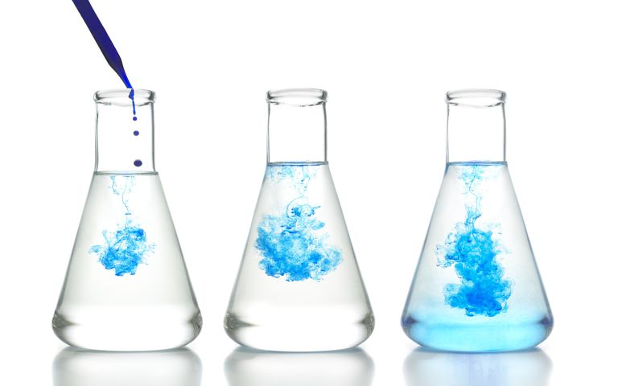

________________________________________________________________________________________________________________________________________________________________________________________________________________________________________________________________________________________________________________________________________________________________

Diffusion occurred (1)

The blue particles spread out from one area to the rest of the liquid, high concentration to low concentration (1).

Section C Extended Answer (9 marks)

Section C consists of 2 questions. Write your answers in the spaces provided. You are advised to spend 10 minutes on this section.

1. The day after an aerobics class. Tam’s muscles felt really sore. Her friend Thuy told her that the pain was due to the lactic acid from the exercise burning the muscles. Is Thuy correct? Explain your answer.

(3 marks)

____________________________________________________________________________________________________________________________________________________________________________________________________________________________________________________________________________________________________________________________________________________

__________________________________________________________________________________________________________________________________________________________________________

__________________________________________________________________________________________________________________________________________________________________________

__________________________________________________________________________________________________________________________________________________________________________

This occurs when muscle cells cannot get oxygen fast enough (1/2) to meet their energy needs through aerobic respiration (1/2). Cell carry out anaerobic respiration/fermentation (no oxygen) (1/2) resulting in build-up of lactic acid causing discomfort (1/2).

2. The cubes of agar jelly below were placed into solutions of potassium permanganate and absorbed the pigment. Explain the results in this experiment. (4 marks)

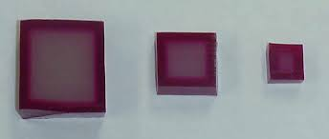

A B C

The agar cubes showed how far the pigment had diffused (1)

The smallest cube had most of its volume changed colour (1/2)

The biggest cube had the least of its volume changed colour (1/2)

Large SA:Vol - small cube (1)

It takes less time/shorter distance for the substance to travel in a smaller cube (1)

_______________________________________________________________________________________________________________________________________________________________________________________________________________________________________________________________

_________________________________________________________________________________________________________________________________________________________________________________________________________________________________________________________________________________________________________________________________________________________________________________________________________________________________________

__________________________________________________________________________________________________________________________________________________________________________

_______________________________________________________________________________________________________________________________________________________________________________________________________________________________________________________________

_________________________________________________________________________________________________________________________________________________________________________________________________________________________________________________________________________________________________________________________________________________________________________________________________________________________________________

__________________________________________________________________________________________________________________________________________________________________________